WEST VIRGINIA HUNITING
CONTEST
100 POINT TOTAL
Fewest shots to get 100 points wins!

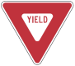
30 Points 20 Points
- 5
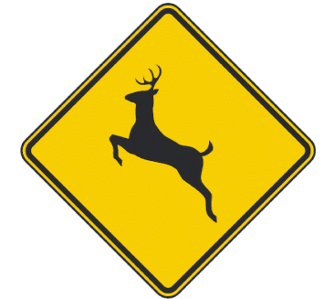
10 Points 50 Points

Hunter: _________________________________

